LAB Brief

Course – Cloud Computing on AWS

**Screenshot for working with EBS volume**

Check the region of the Aws

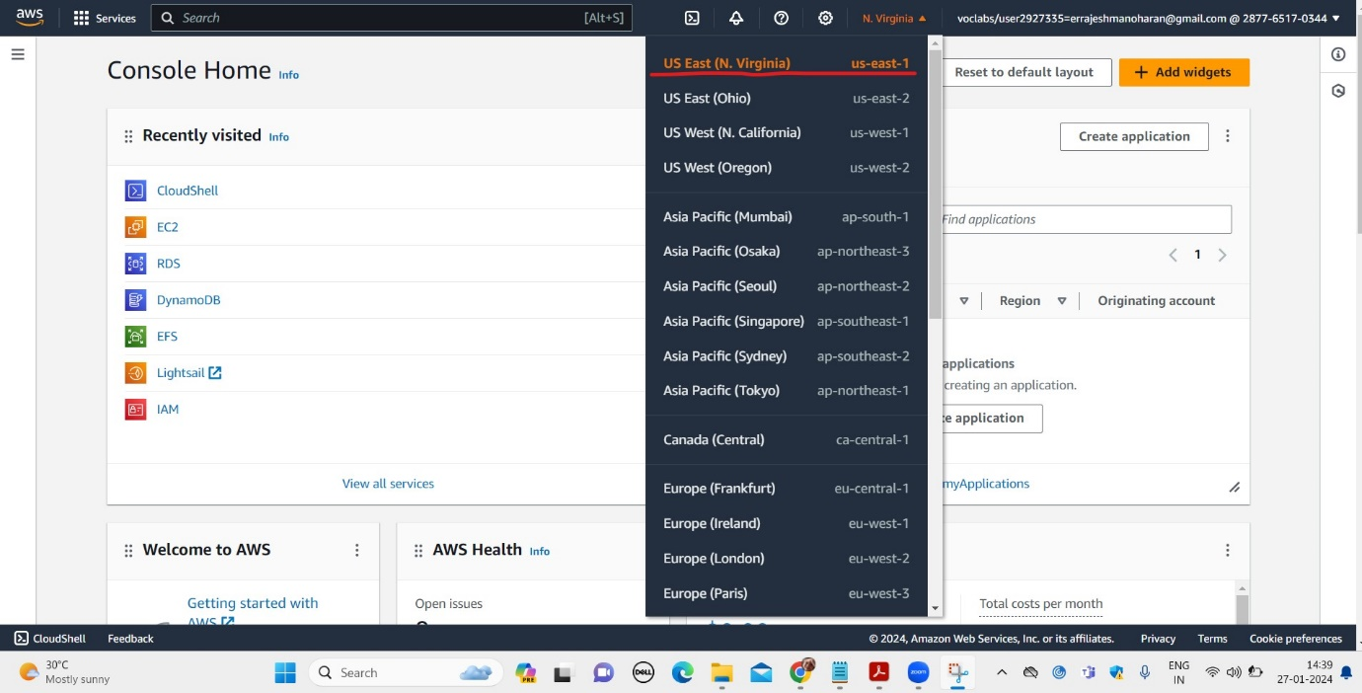

EC2 instance creation

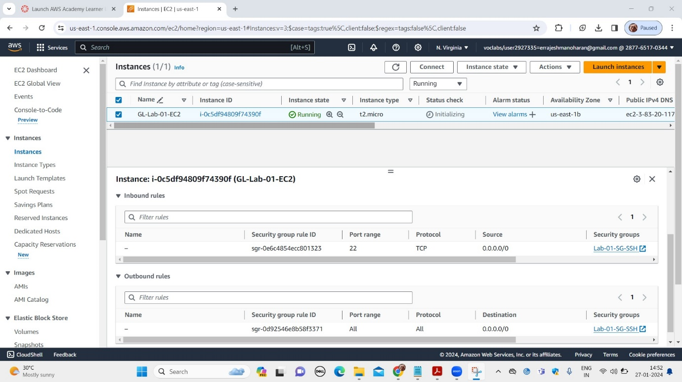

Connecting to EC2 instance

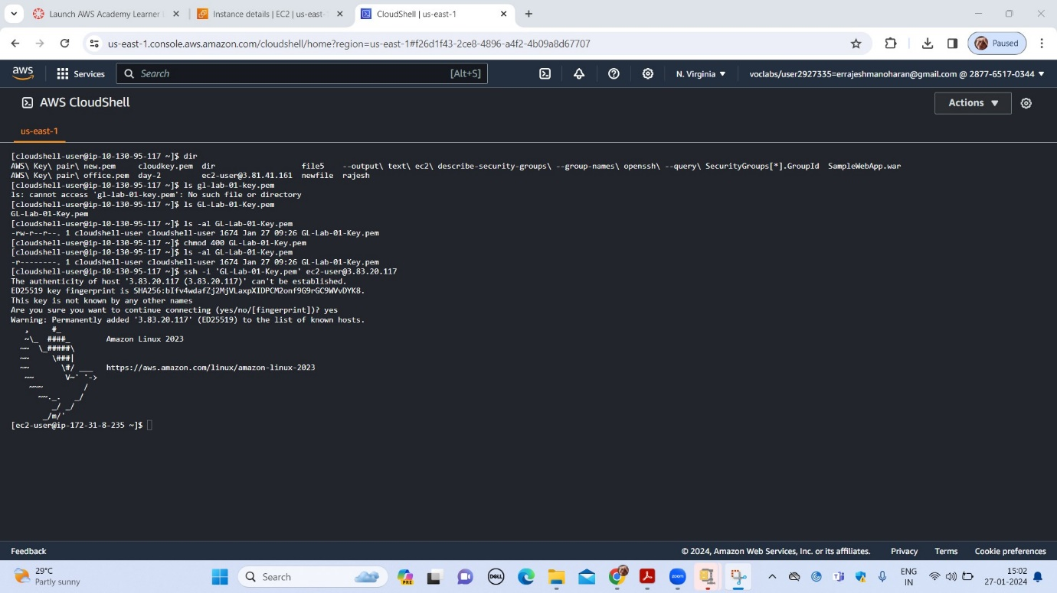

Creation of a new volume of 10Gib

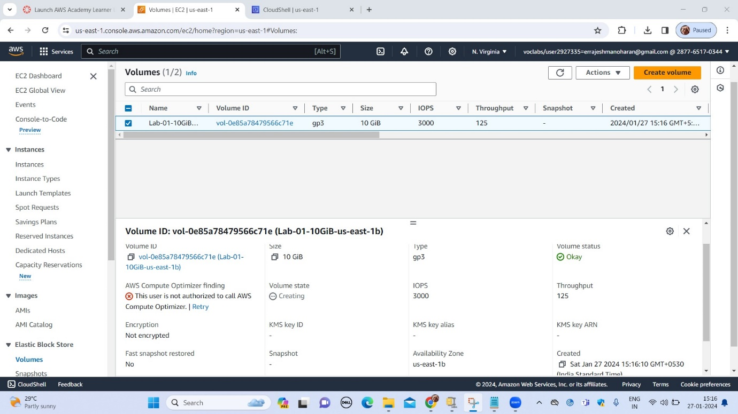

Attach additional volume to EC2 instance

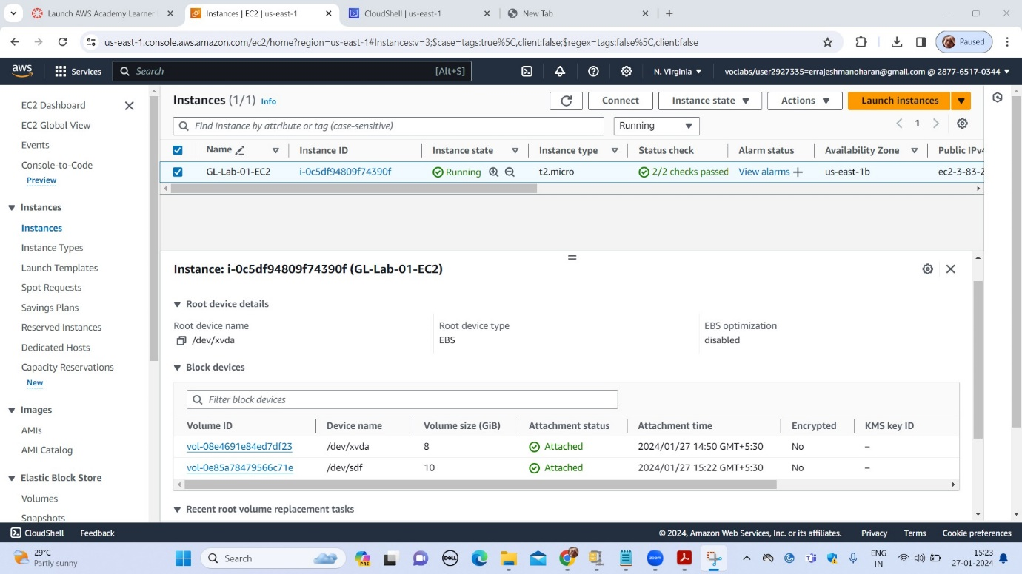

EC2 instance with additional volume

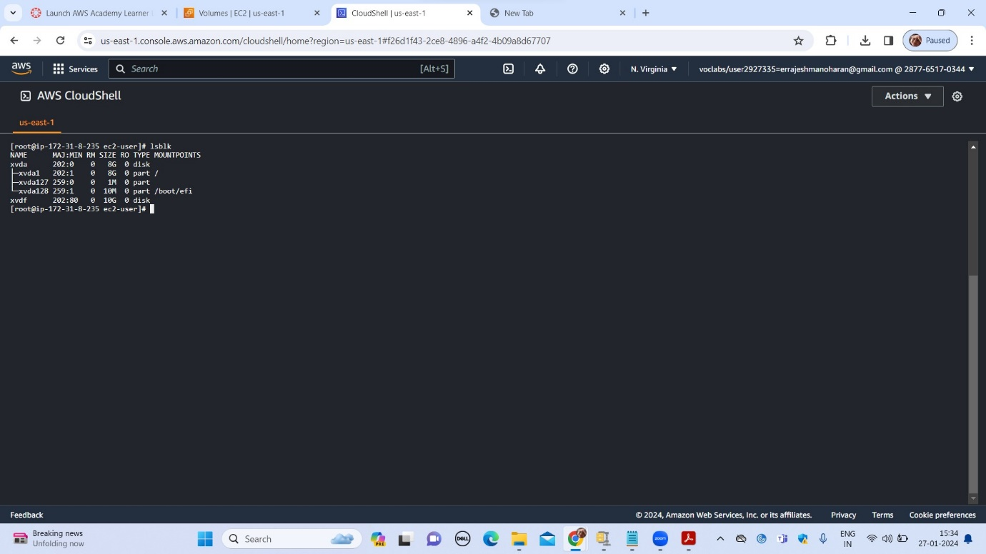

Formatting of the disk

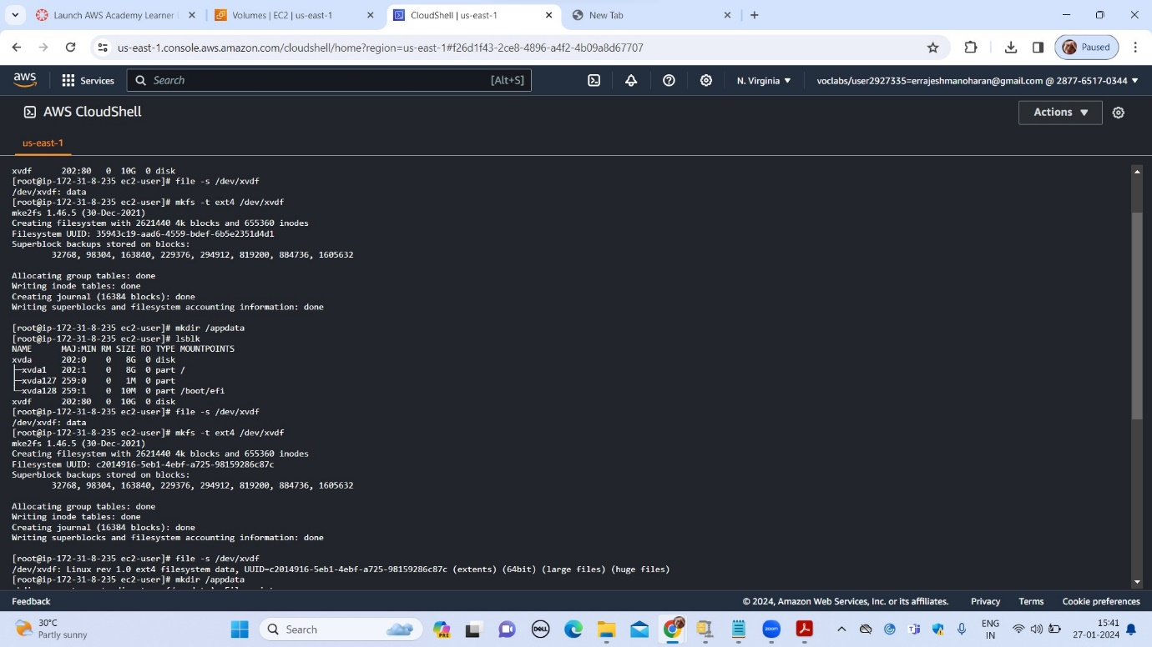

After mounting the new volume

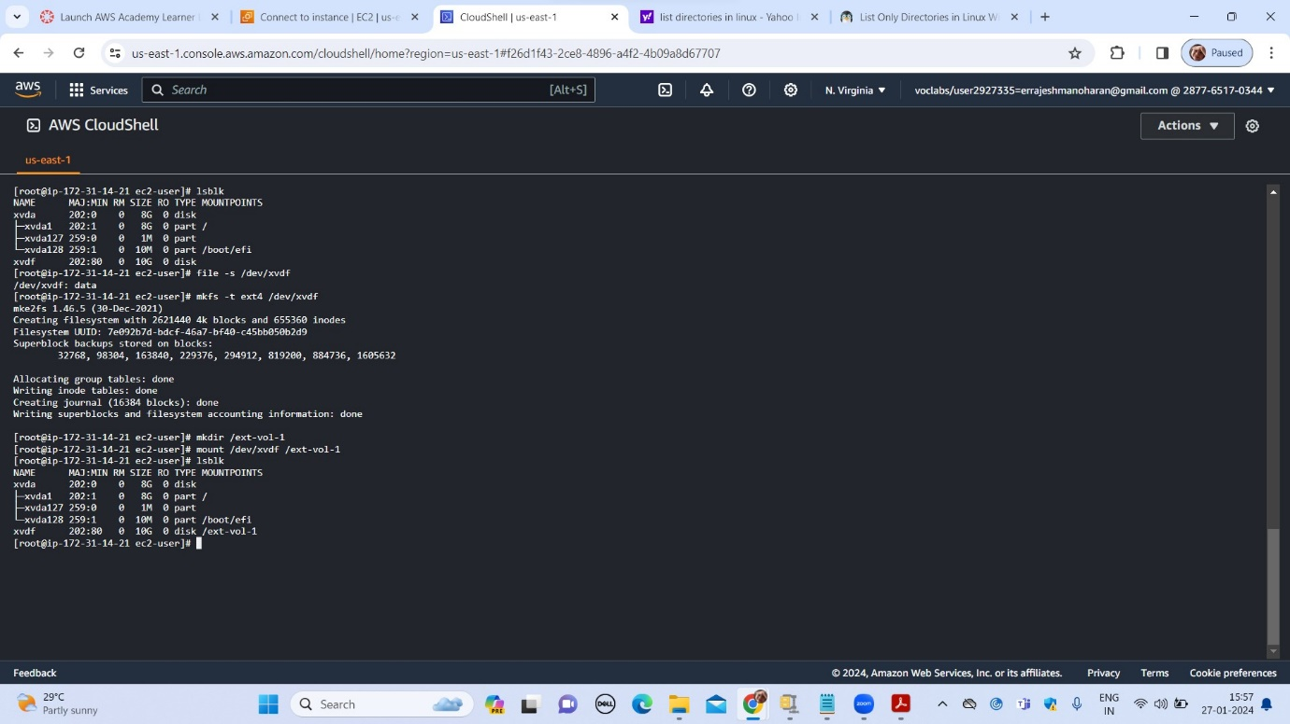

Creating a new file in the additional volume

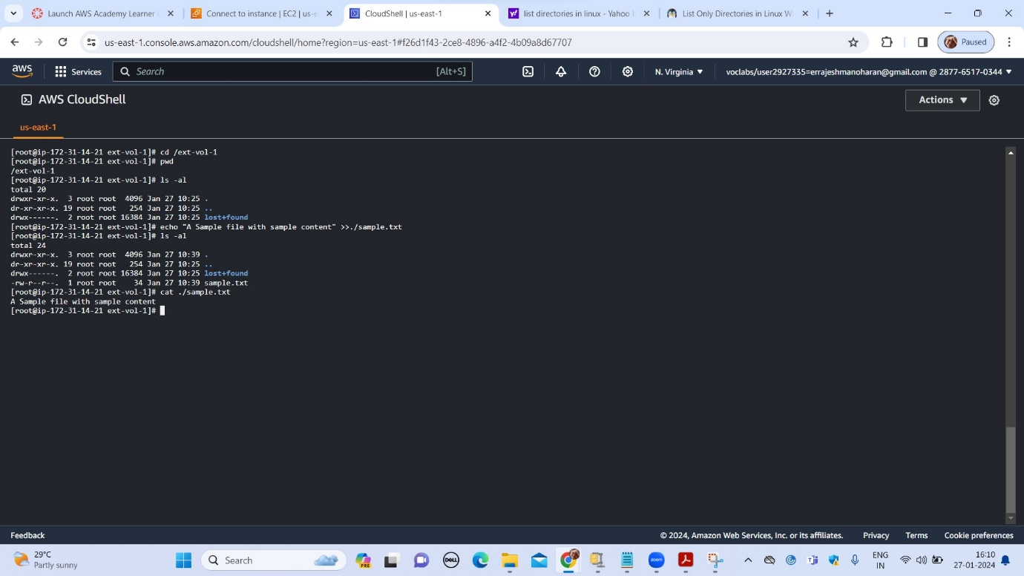

Unmounting the volume from EC2 instance

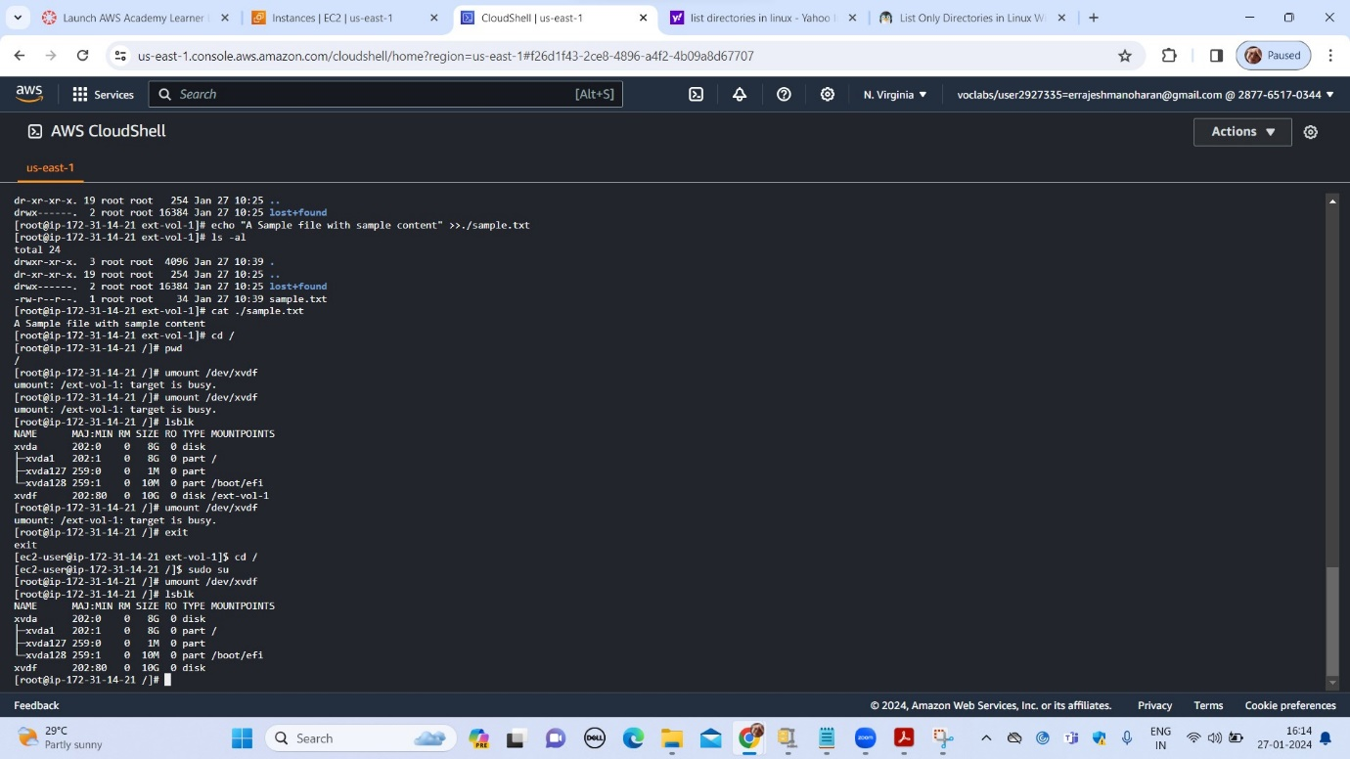

Deattach the additional volume

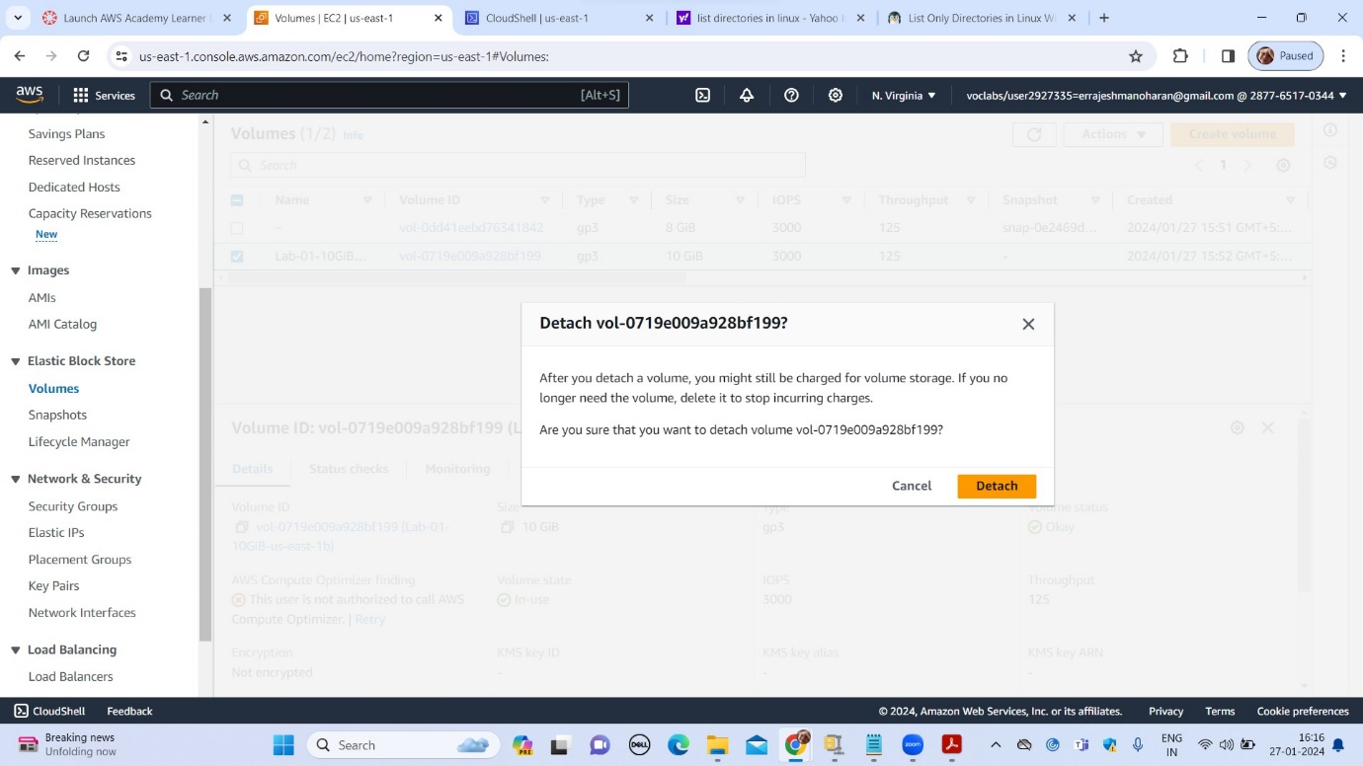

Status of the additional volume after deattachment

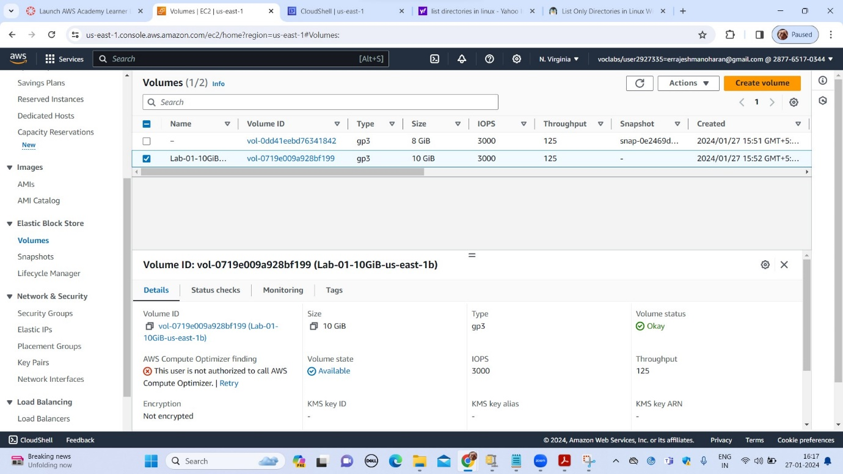

Taking snapshot of the 10GiB additional volume

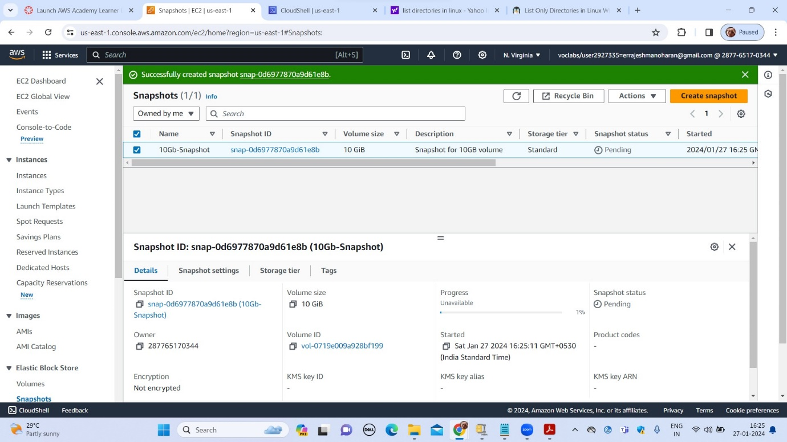

Creating a new 15GiB additional volume using the snapshot

`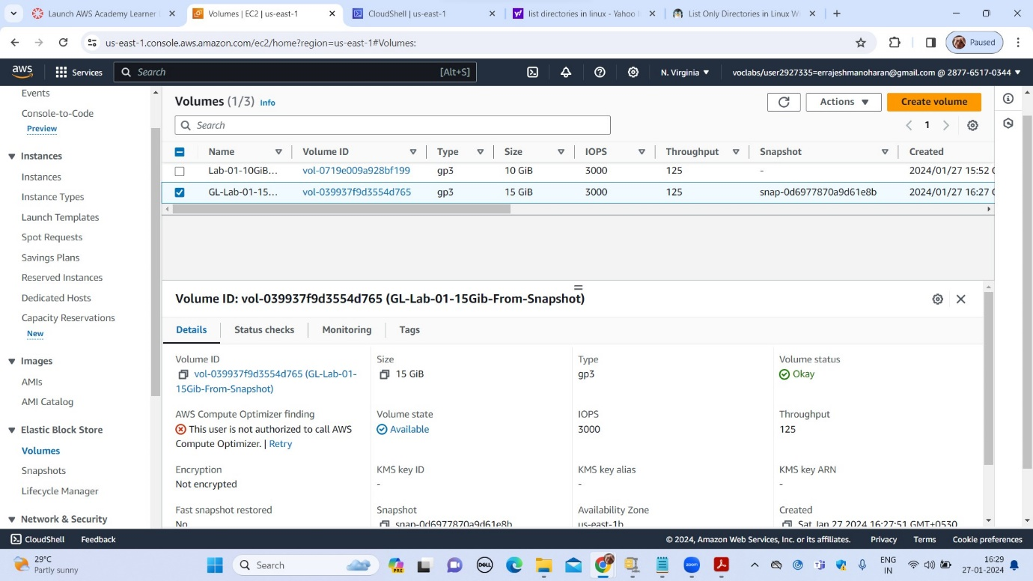

Attaching the newly created volume to EC2 instance

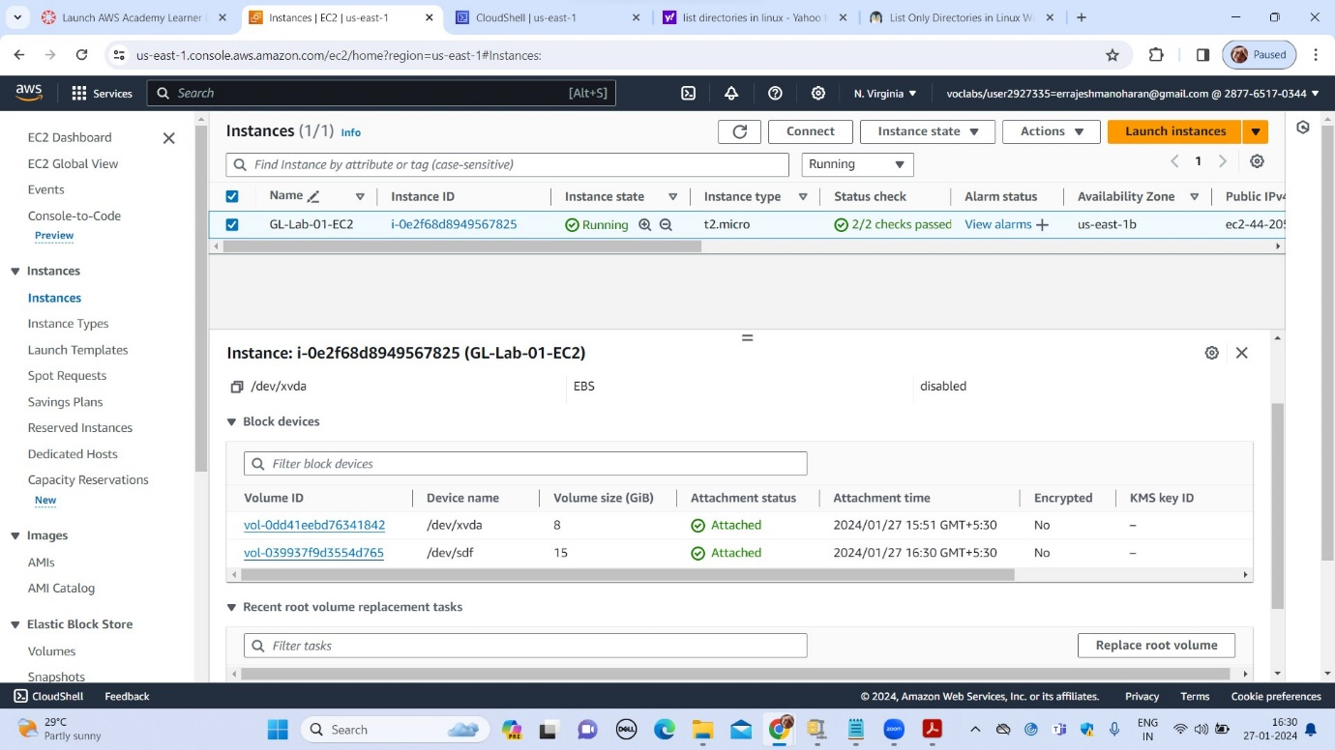

New volume after attaching to EC2 instance

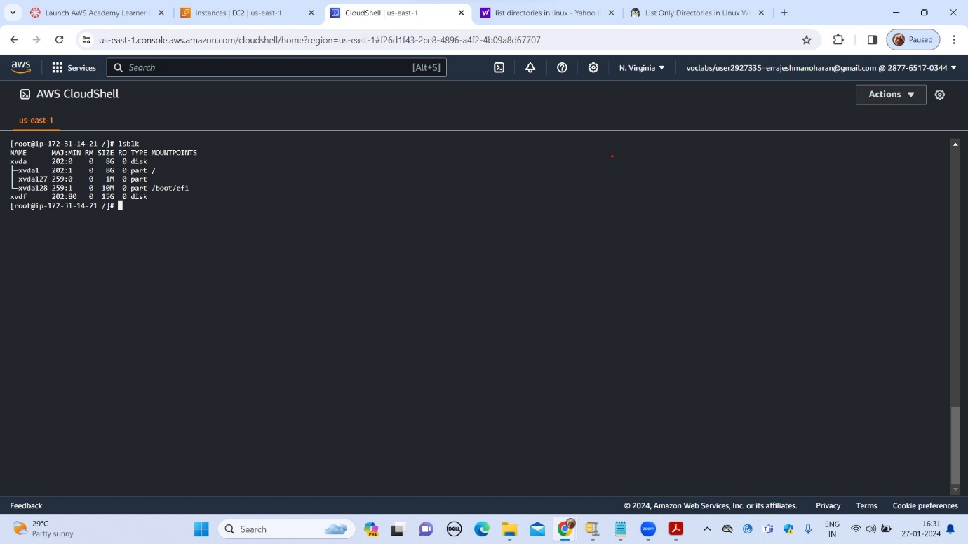

Formatting of new volume is not required as it was created from the snapshot

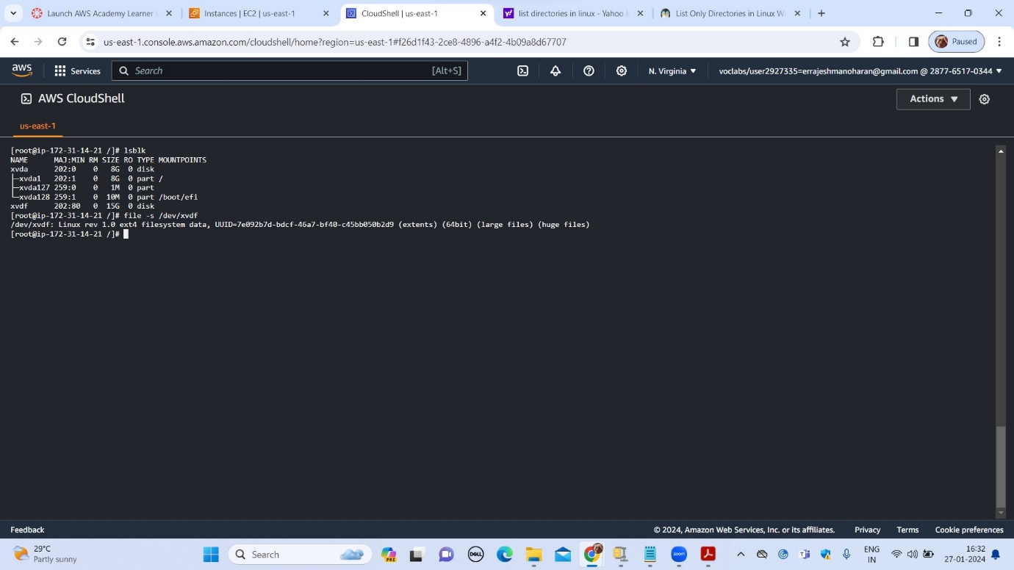

After mounting the new volume

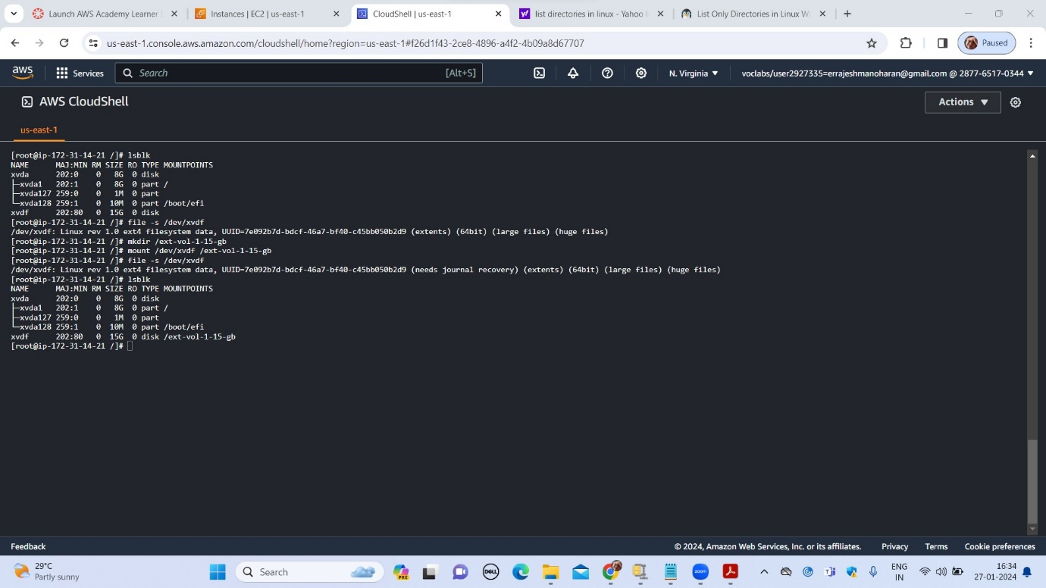

Opening the same file which was saved in the 10GiB storage

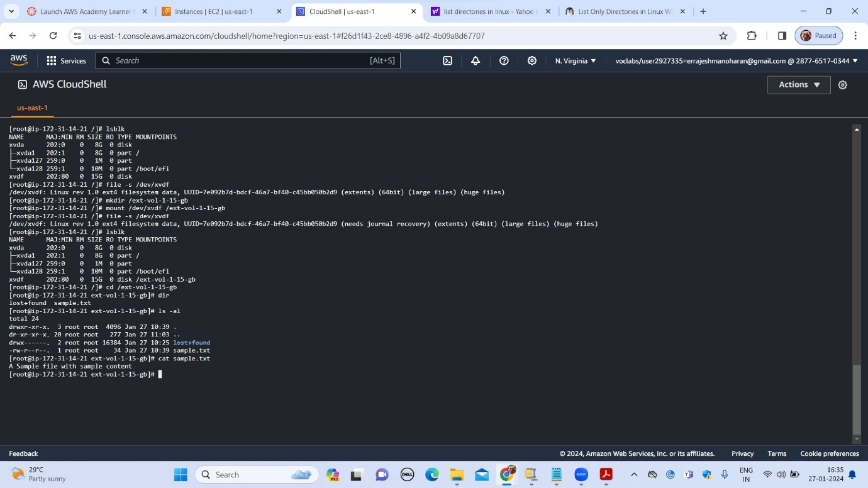

Unmouting the additional volume

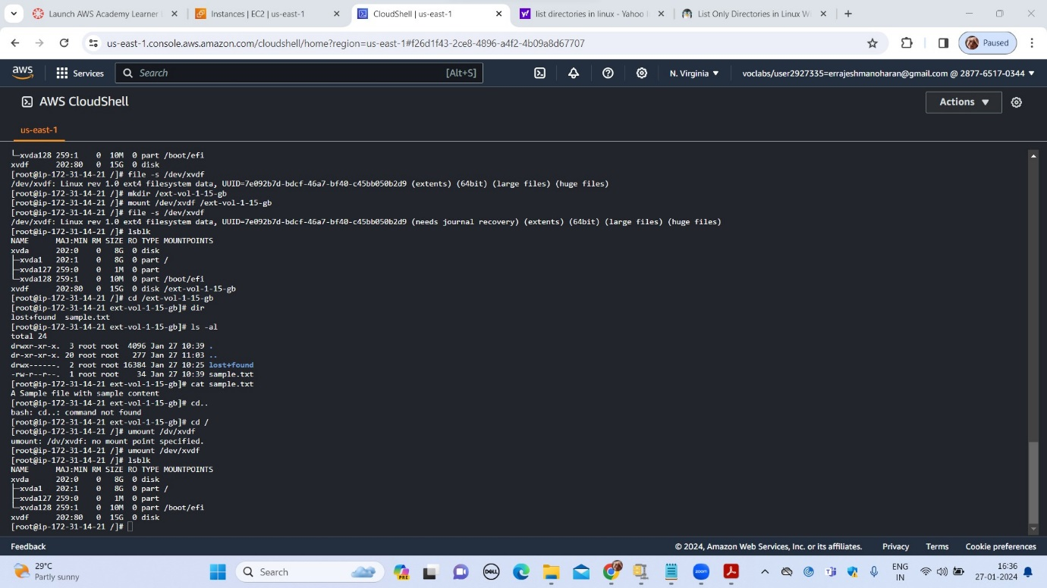

Deattach the new volume

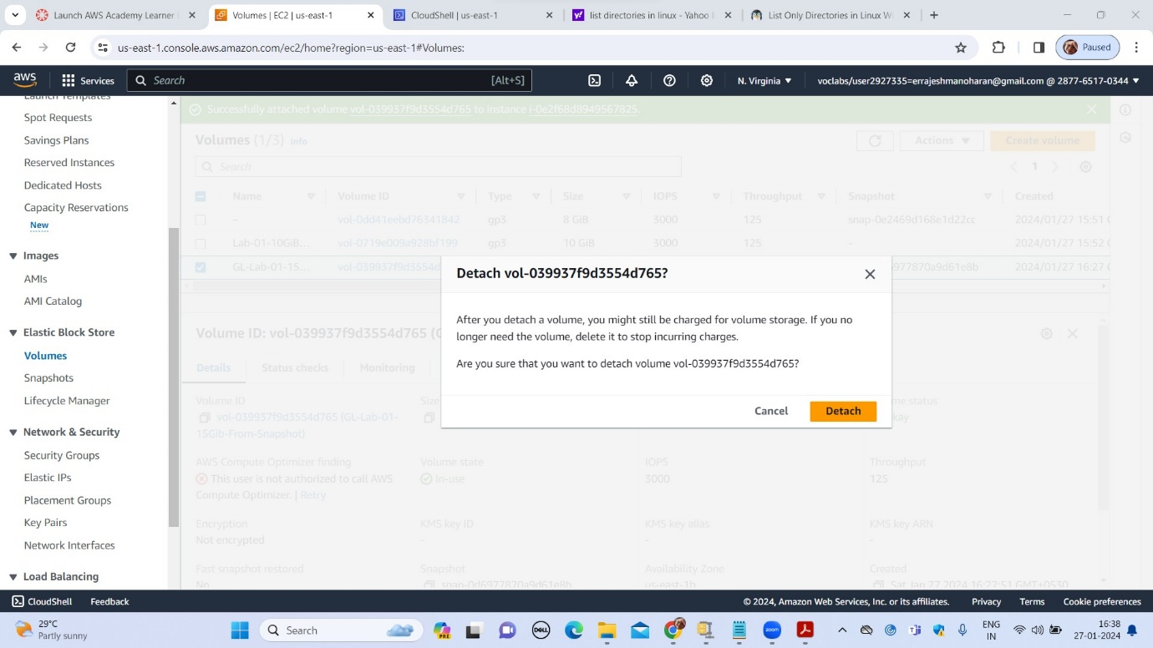

Successful deattachment of new volume

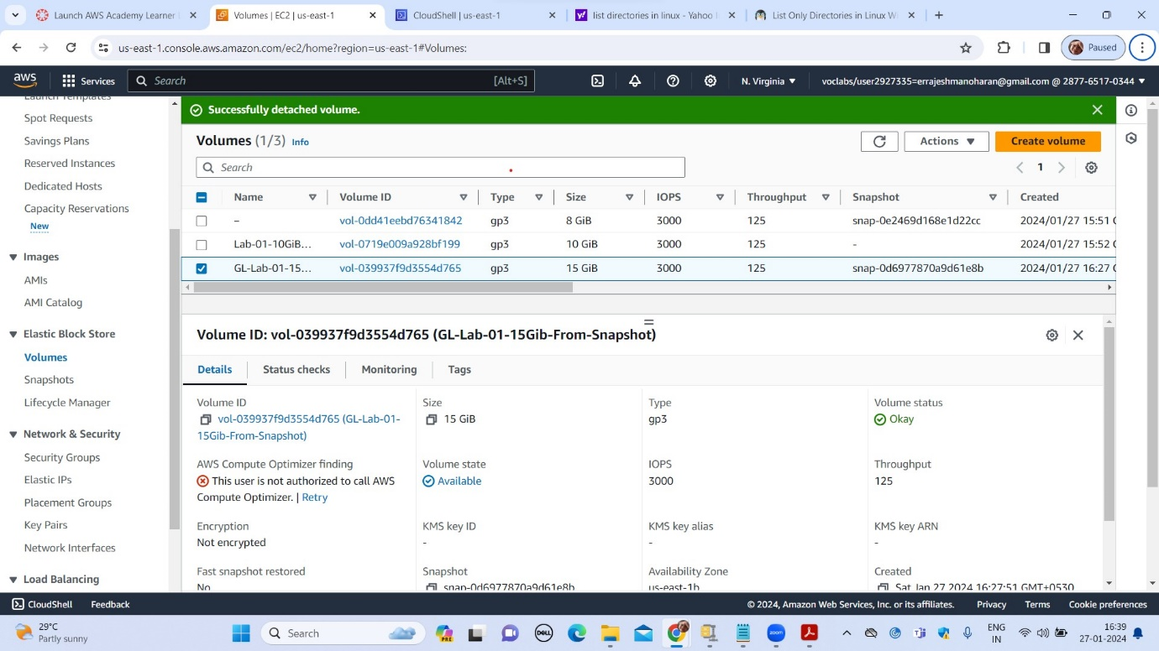

Creation of S3 bucket

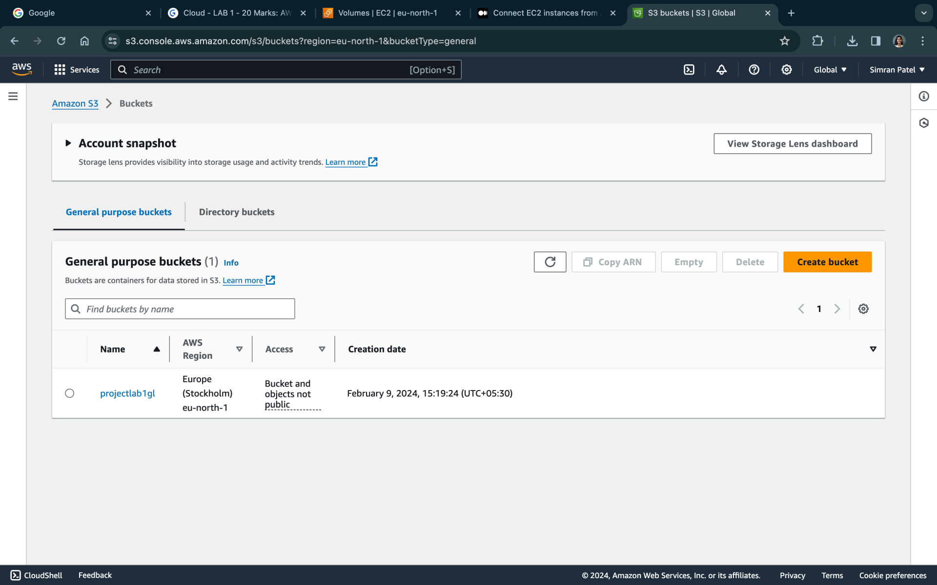

S3 bucket properties

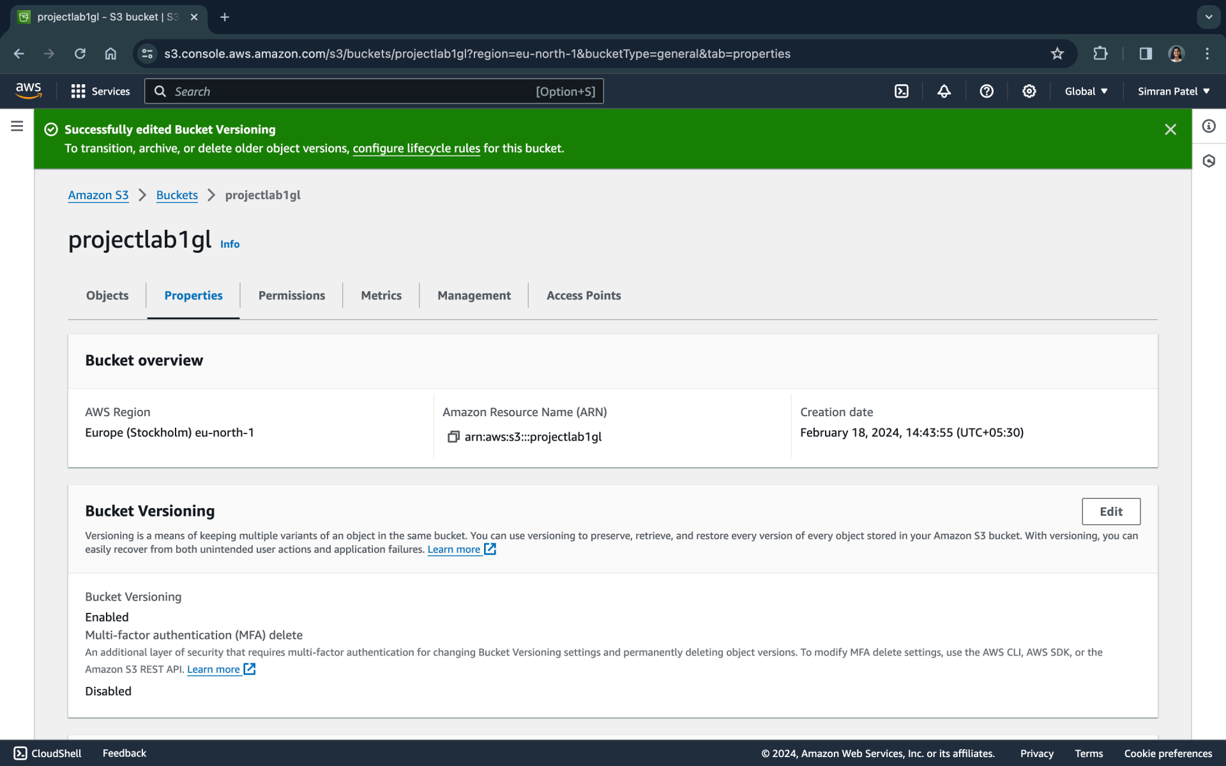

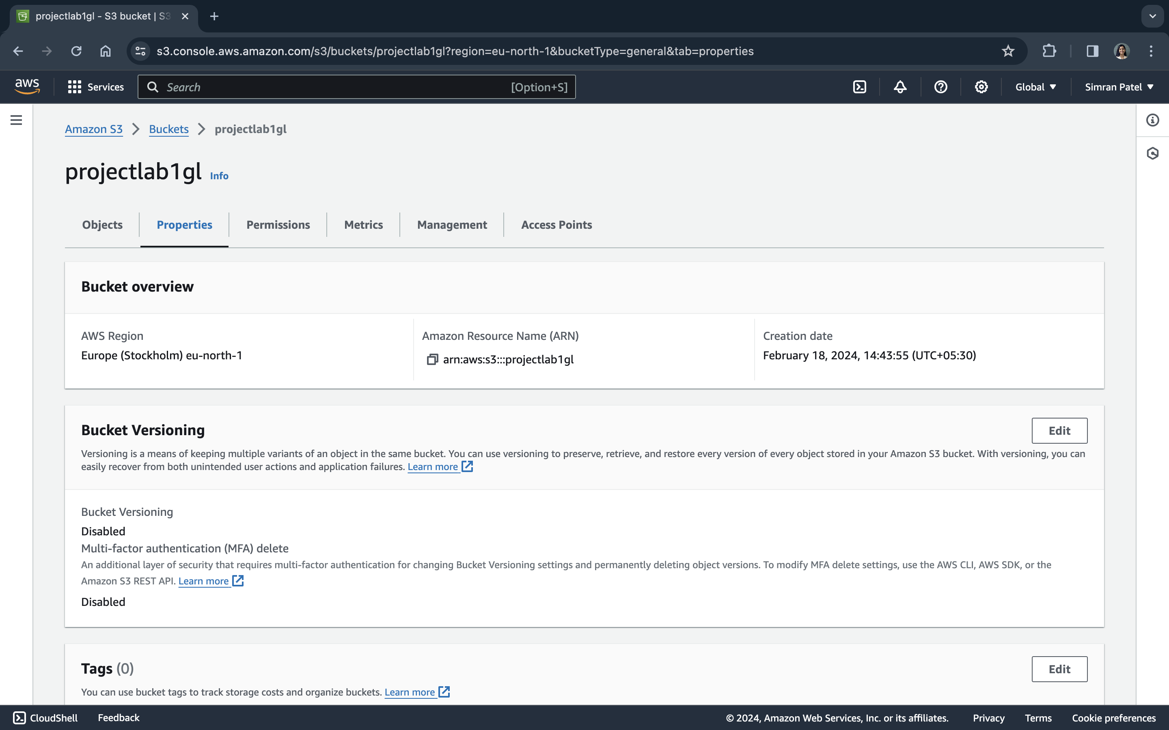

S3 buckets project folder

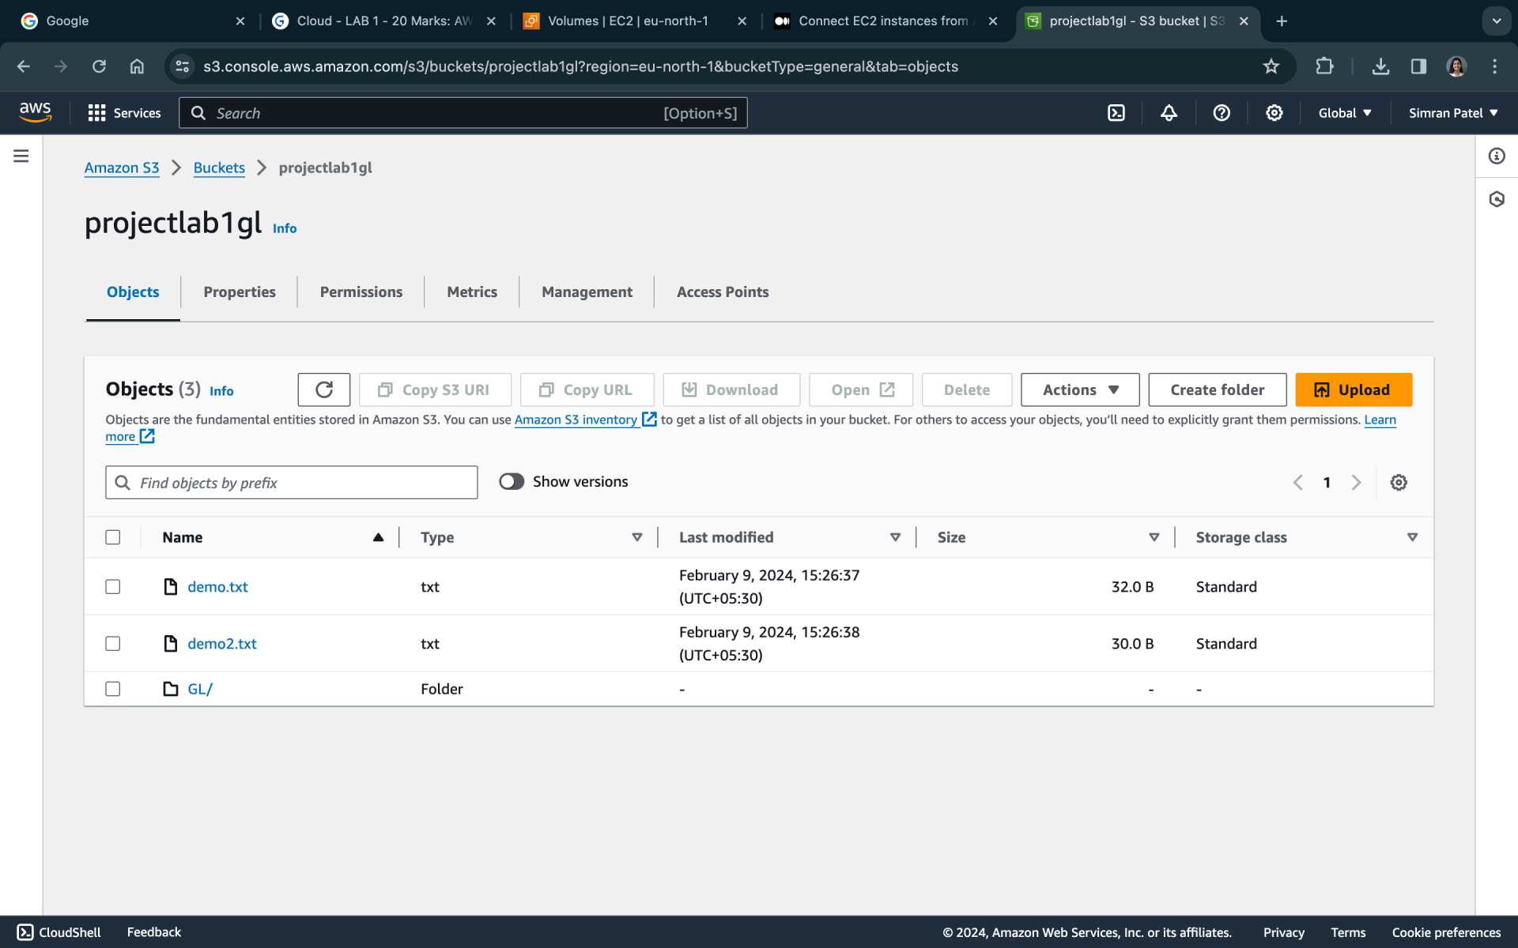

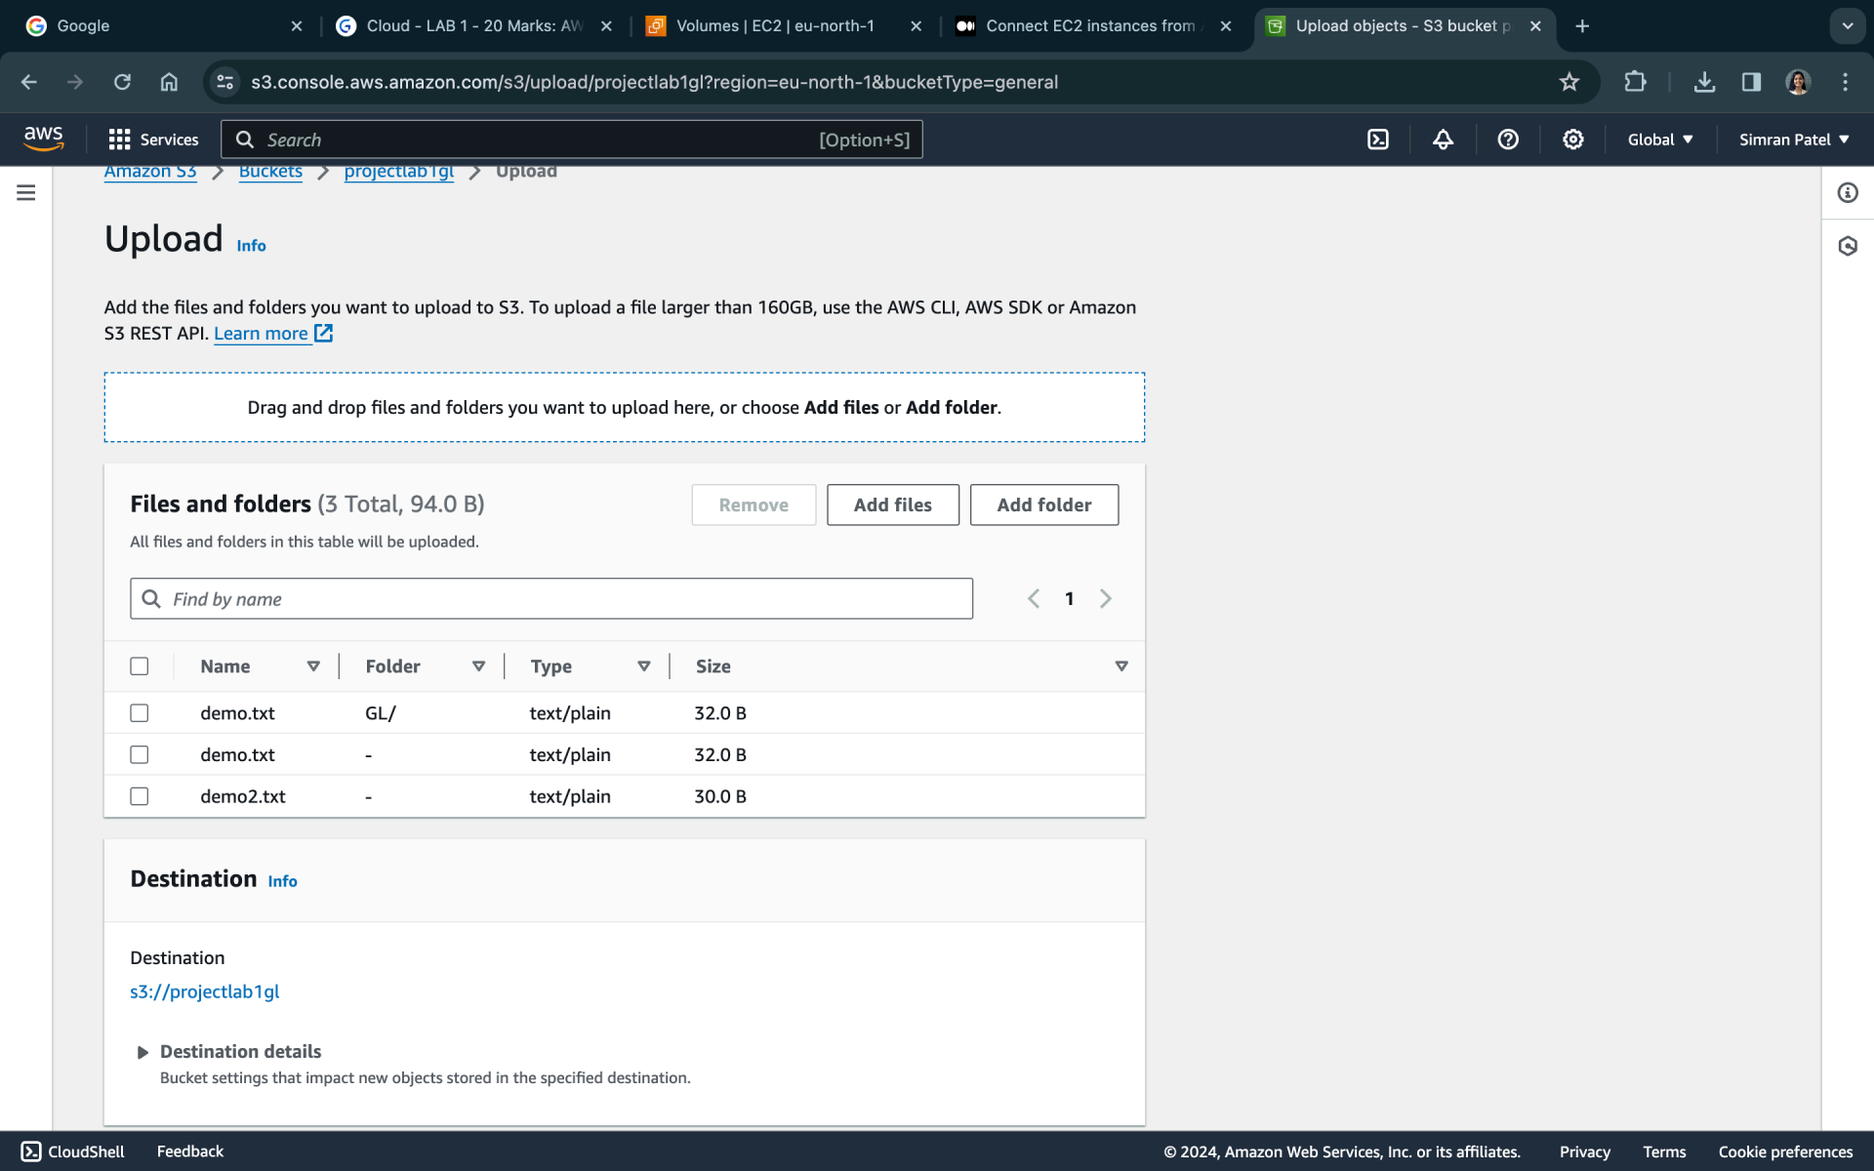

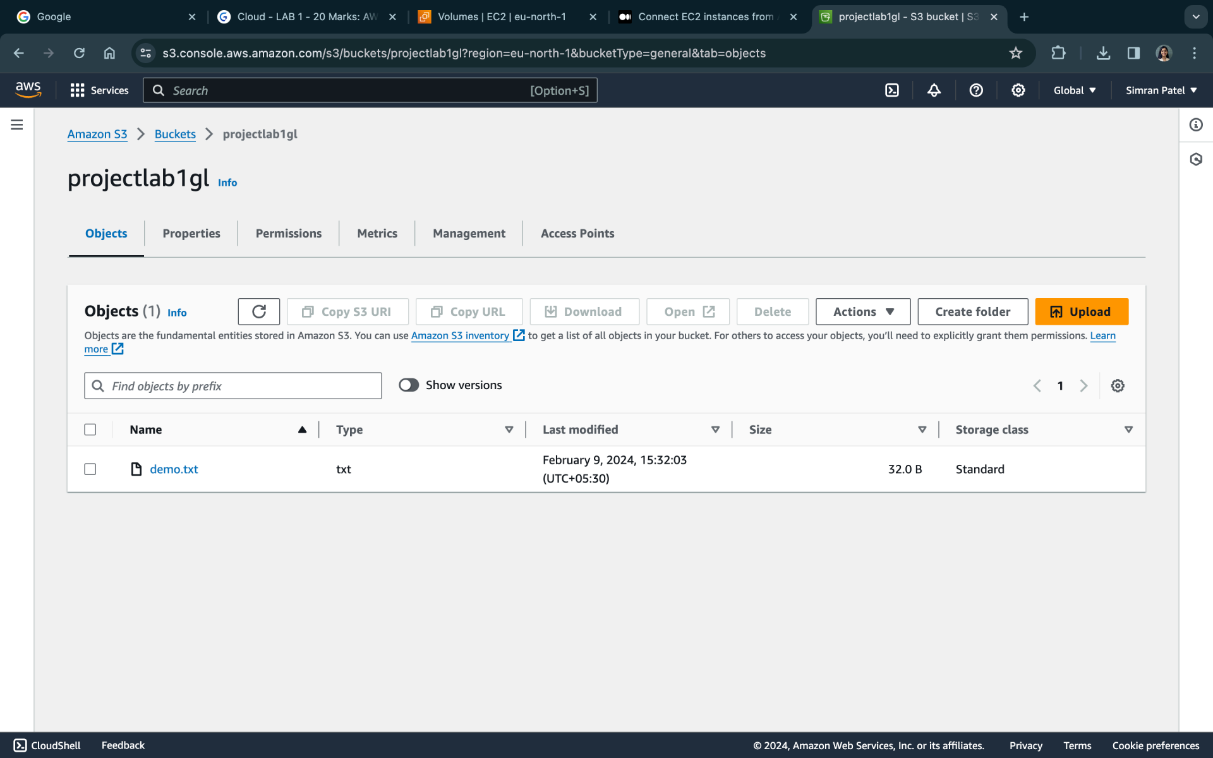

List the files in S3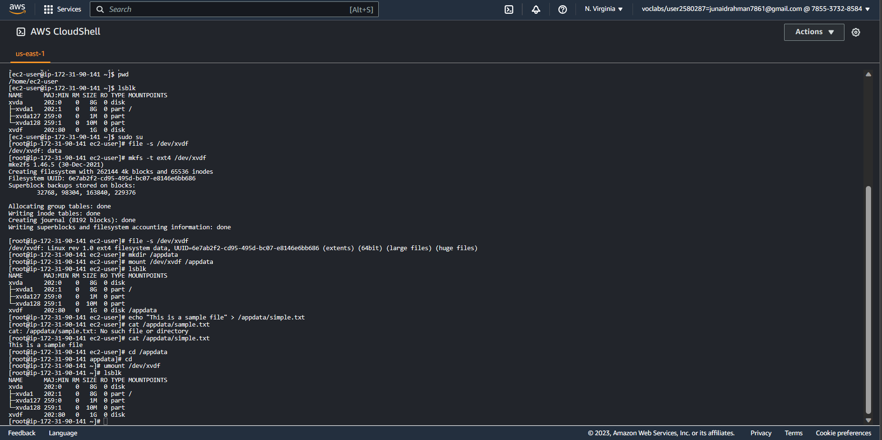

Creating one more folder in S3 bucket

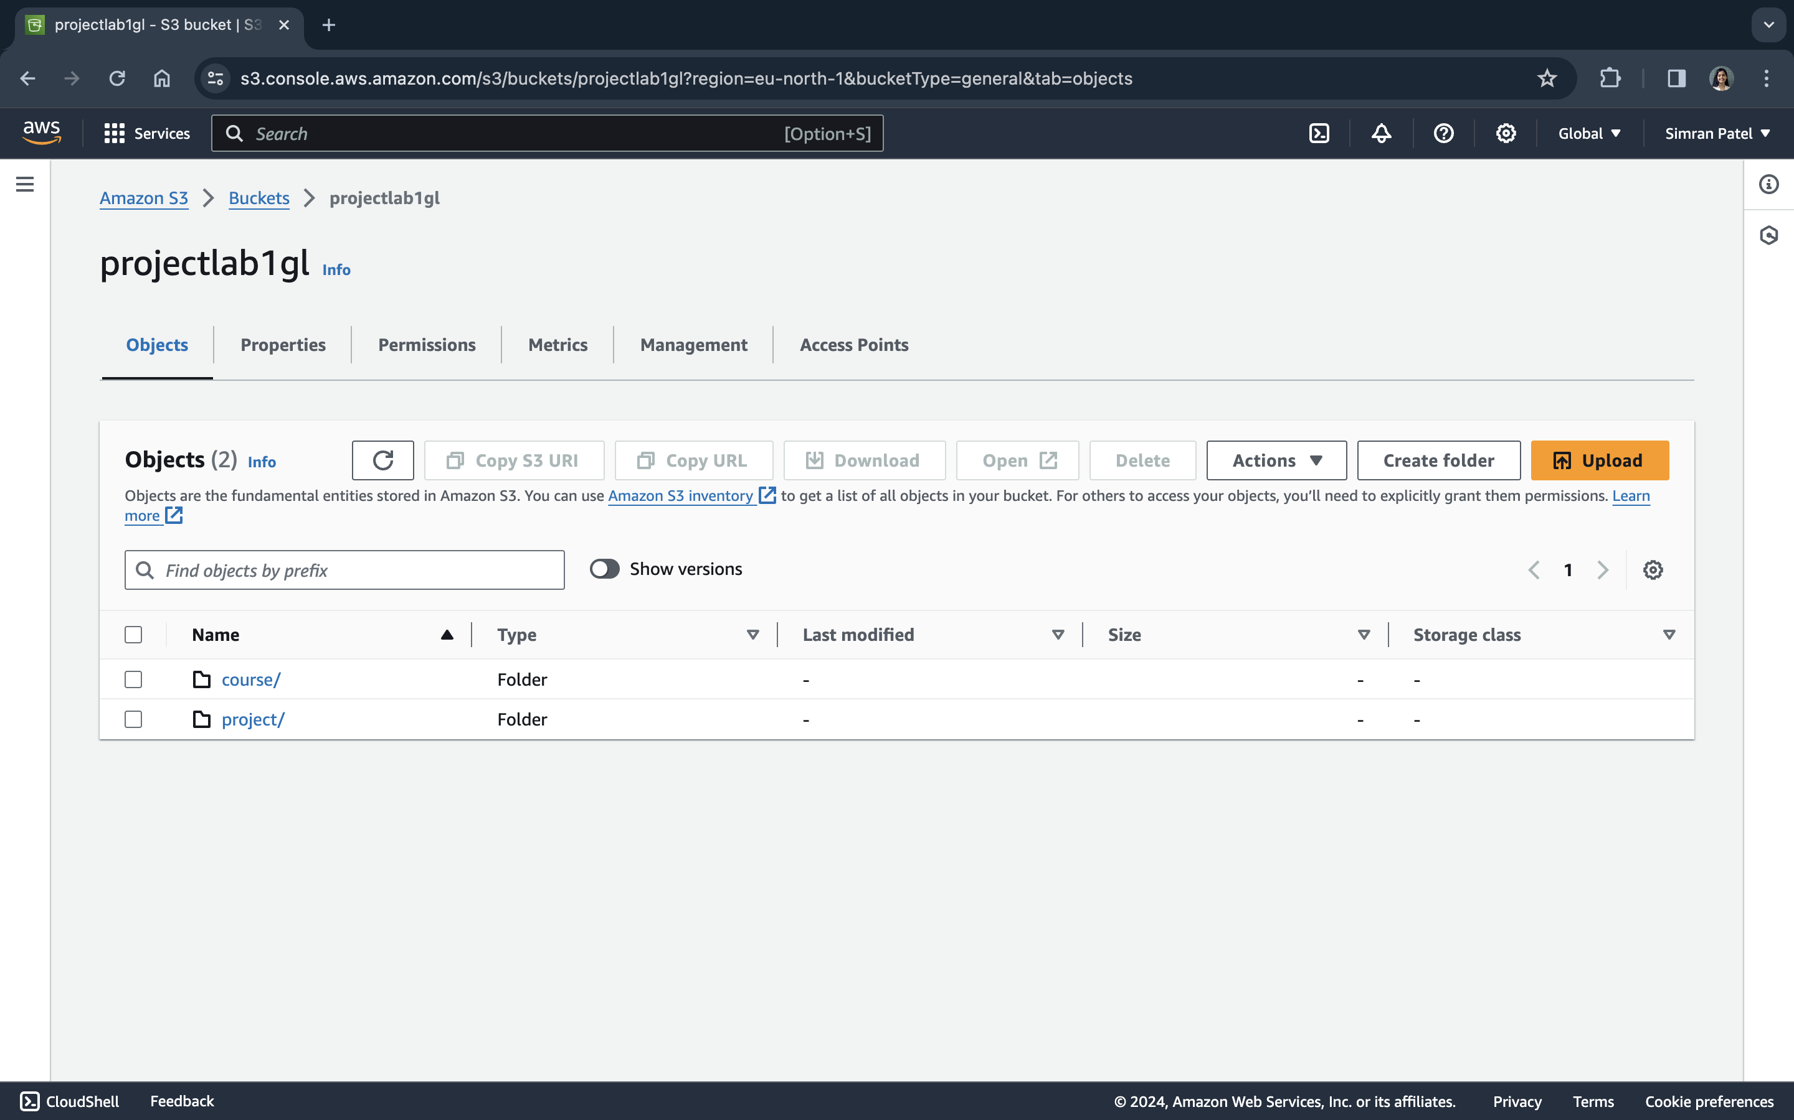

Source and replica buckets

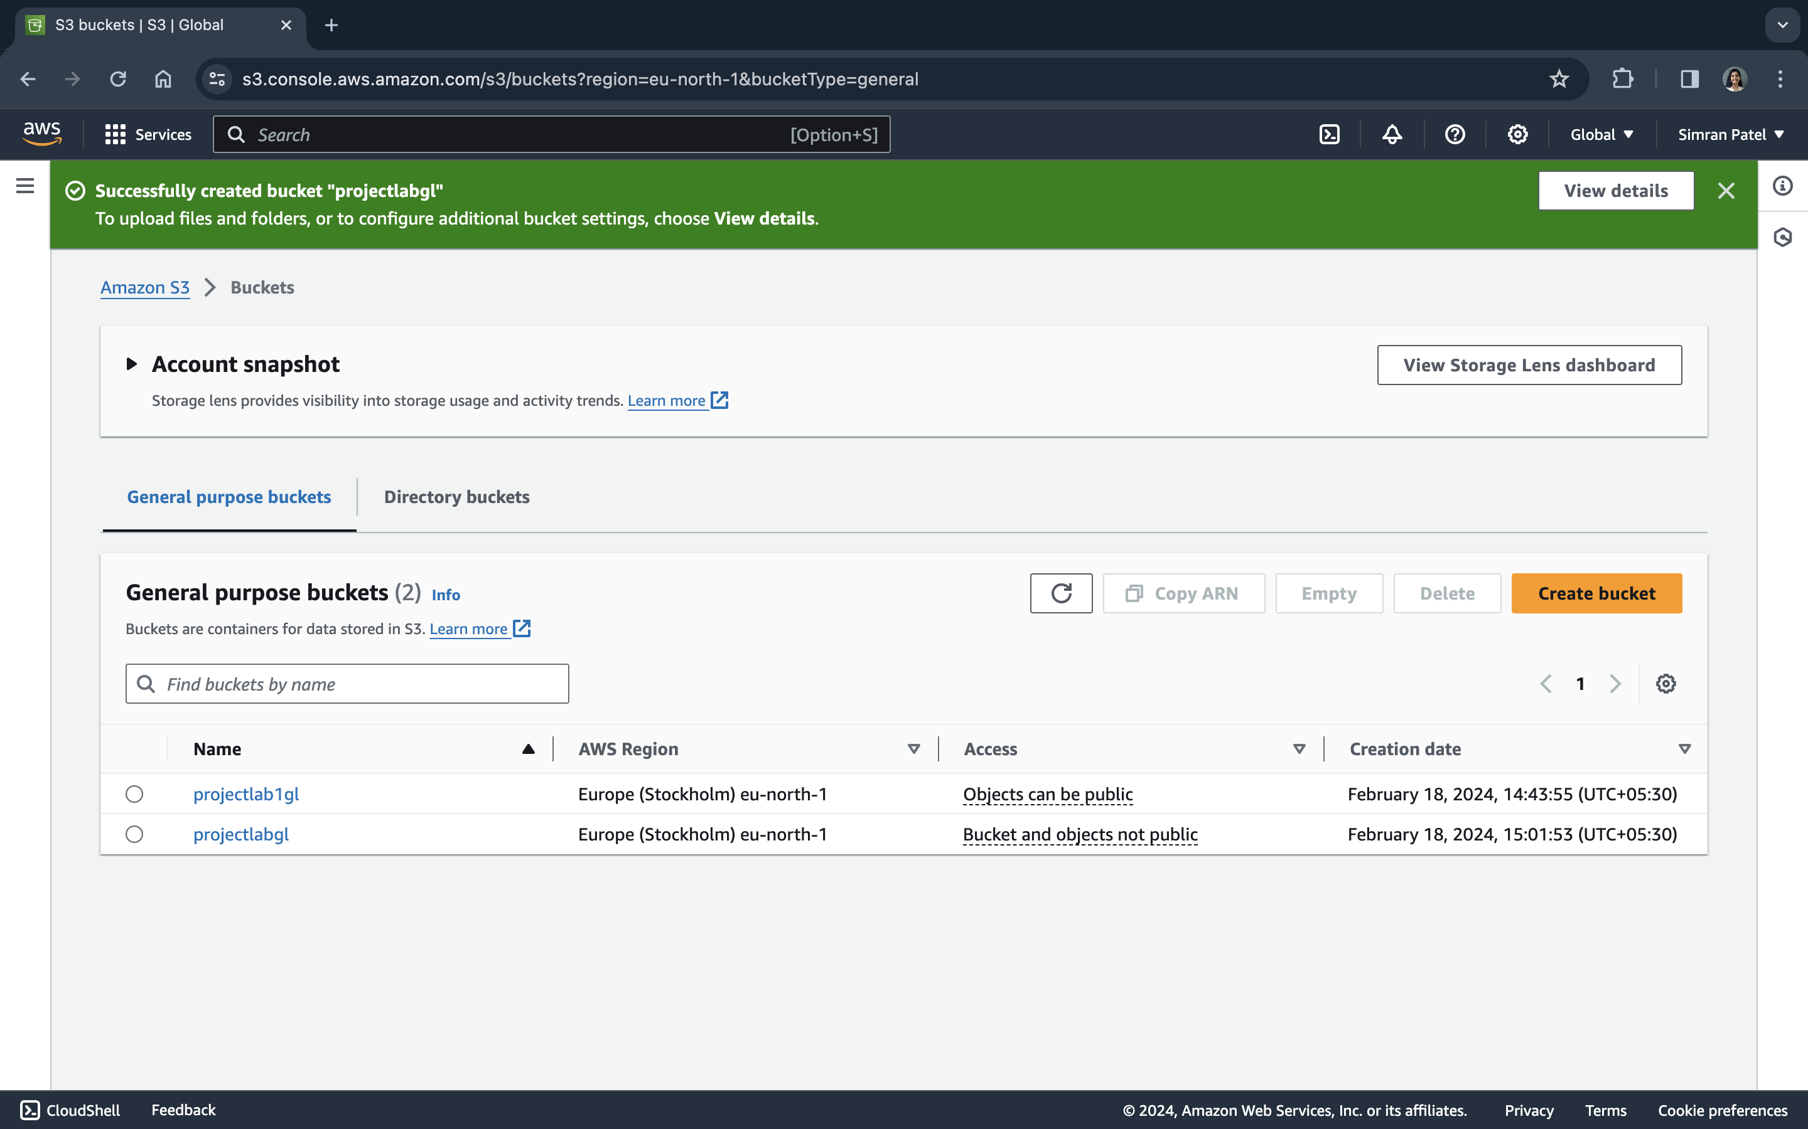

Replication rules after setting up

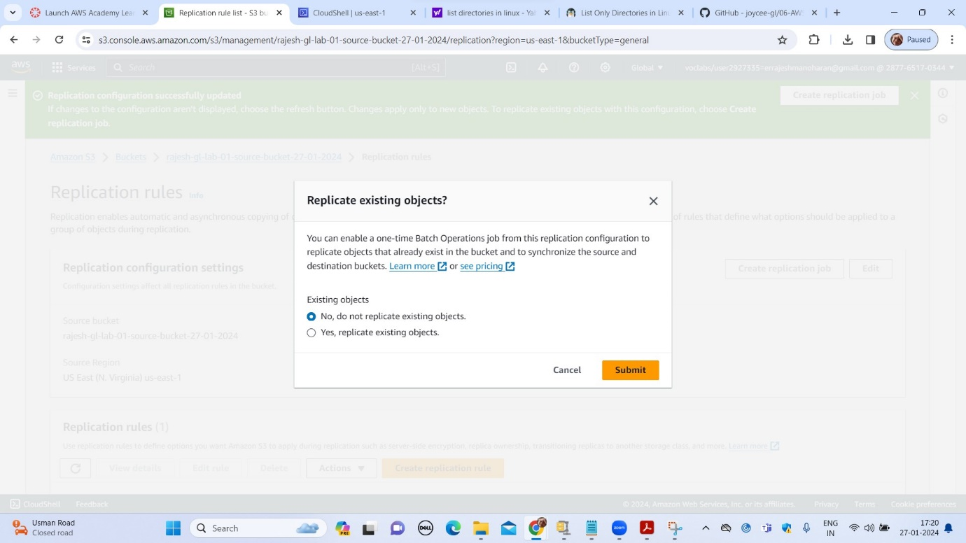

Please note since we selected **“No, do not replicate existing objects”** the new s3 bucket did not have the folders/files as so0urce

New files added in source S3 tab

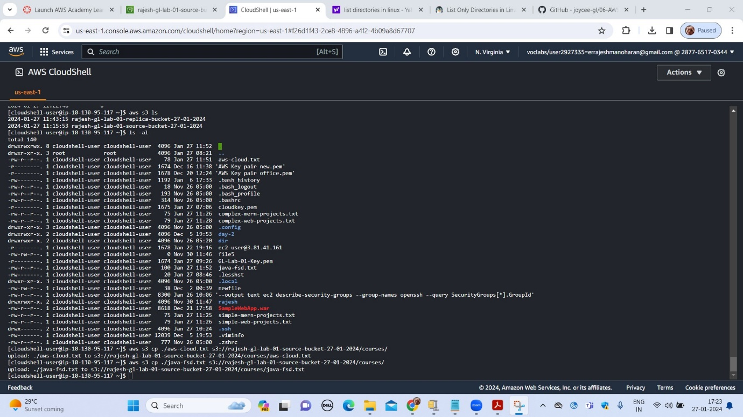

Showing source S3 bucket with the new file

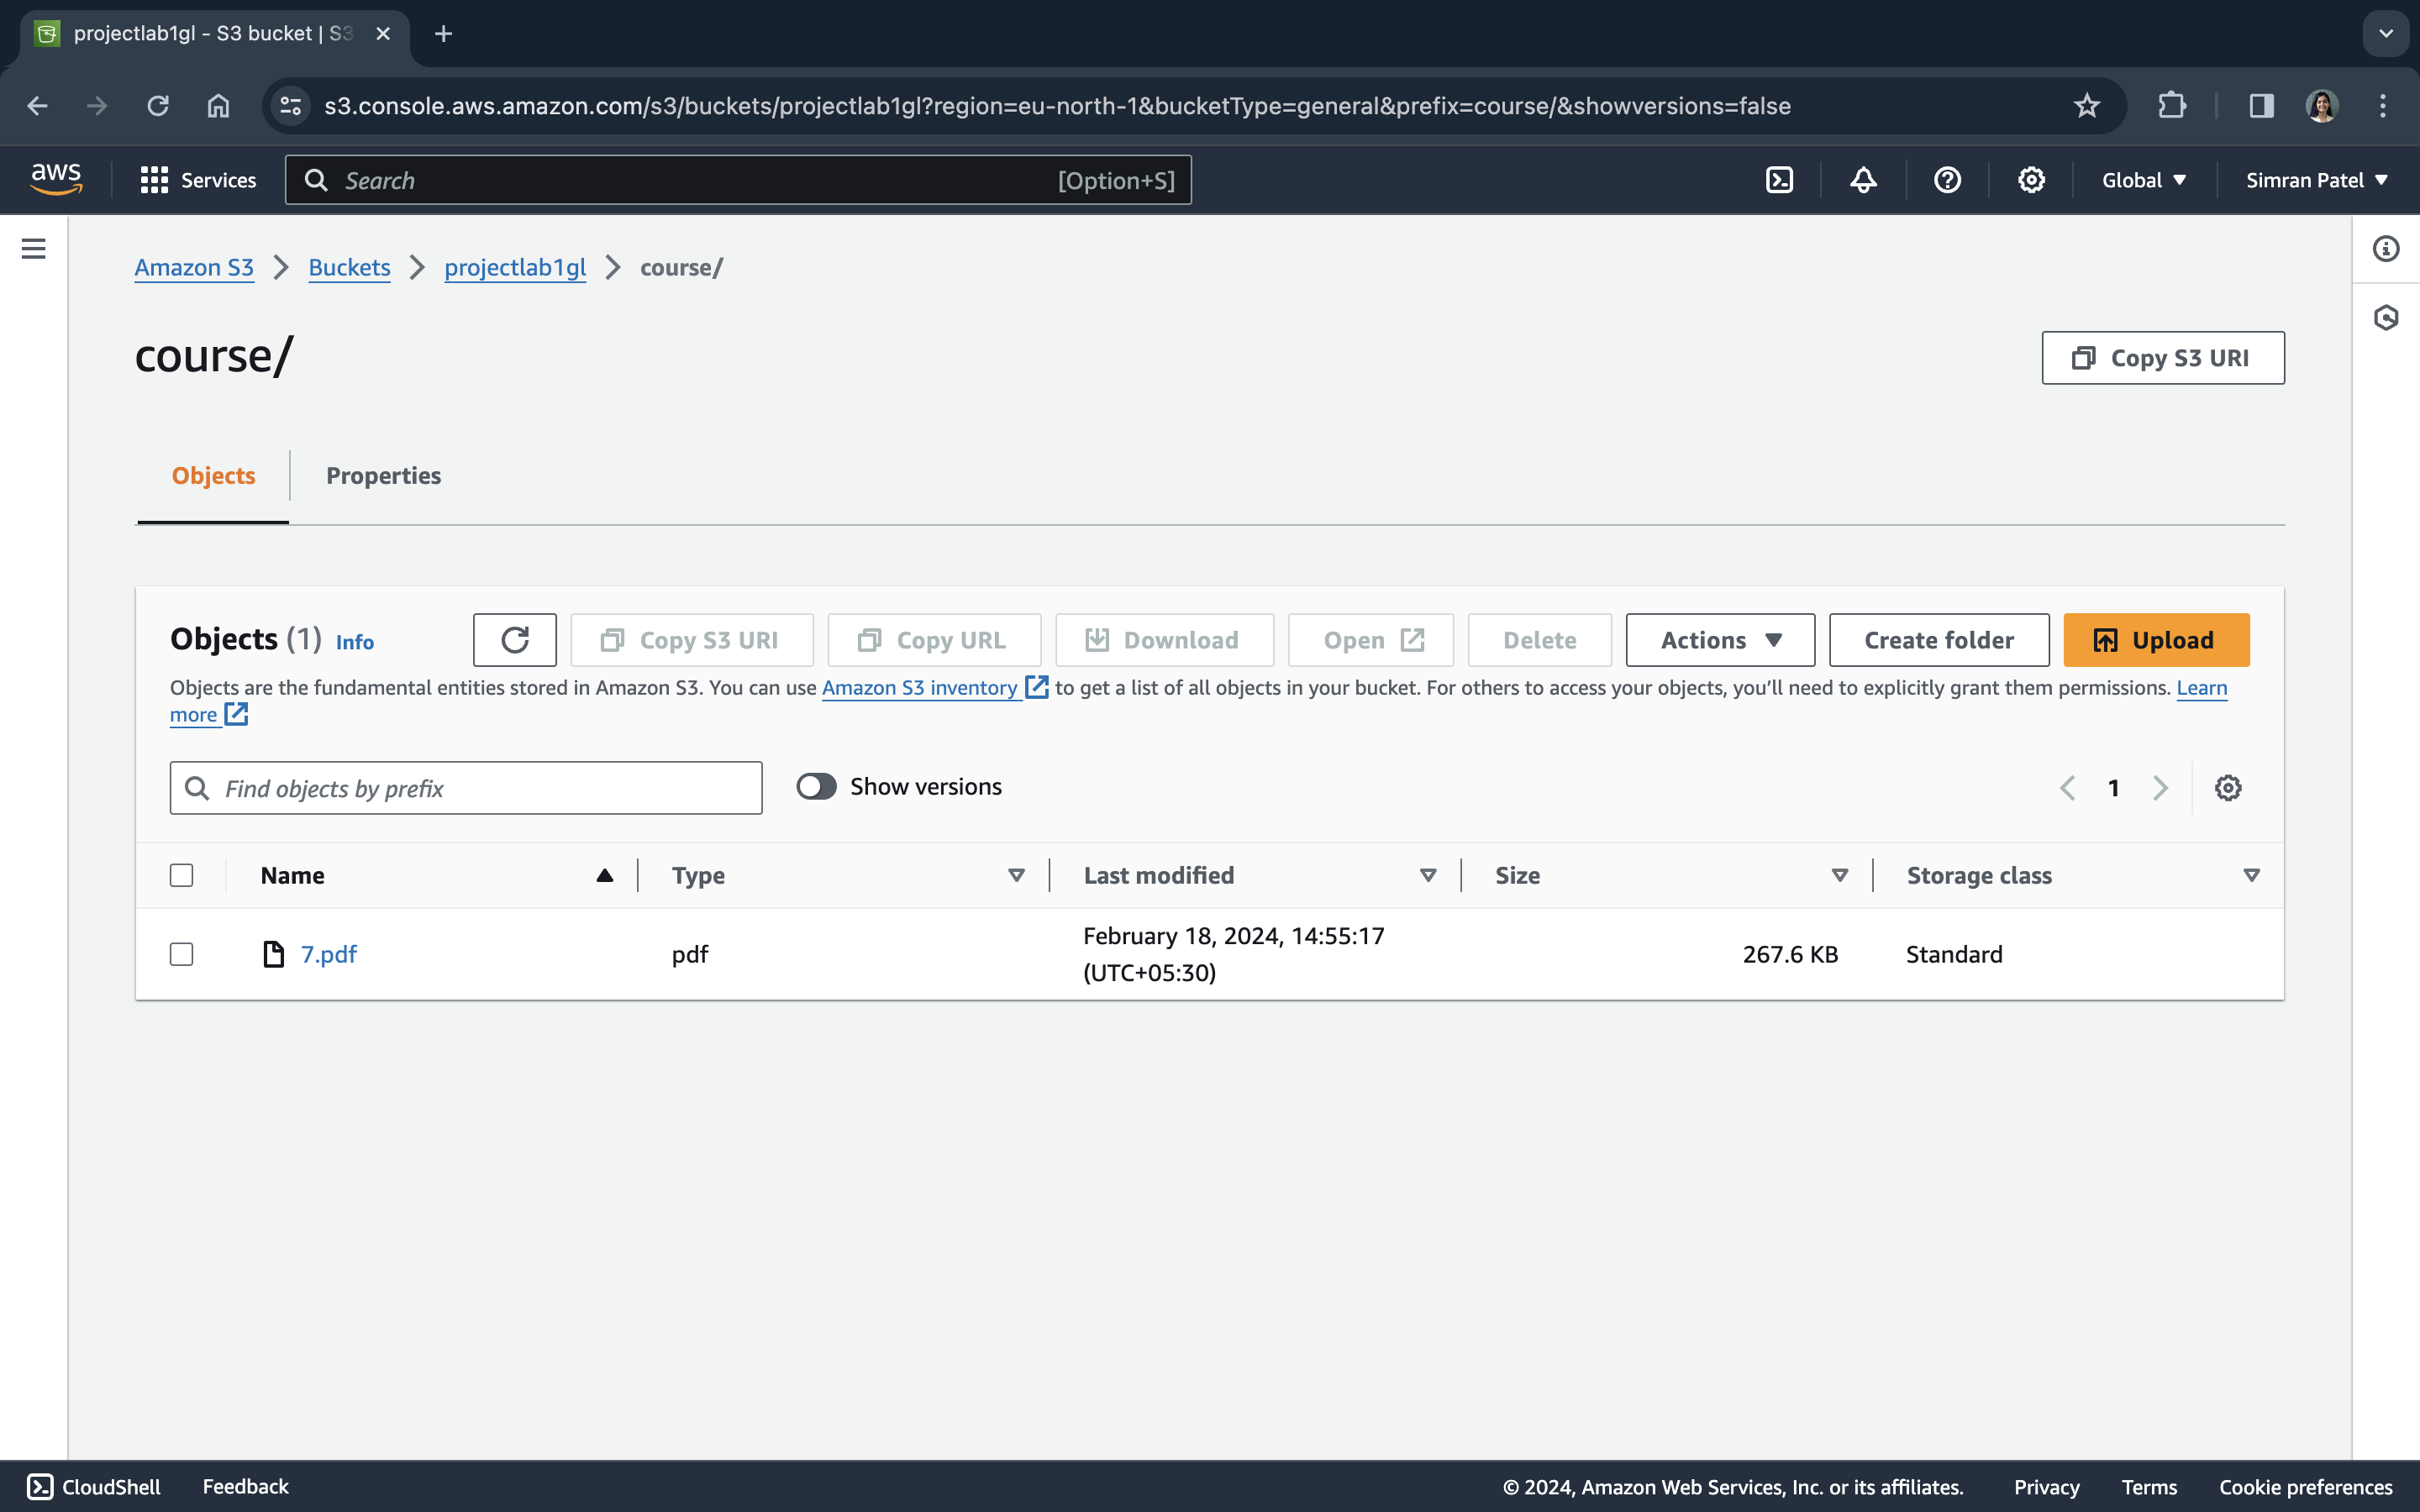

New files which were added after the replication rule set were replicated below screenshot verify the same

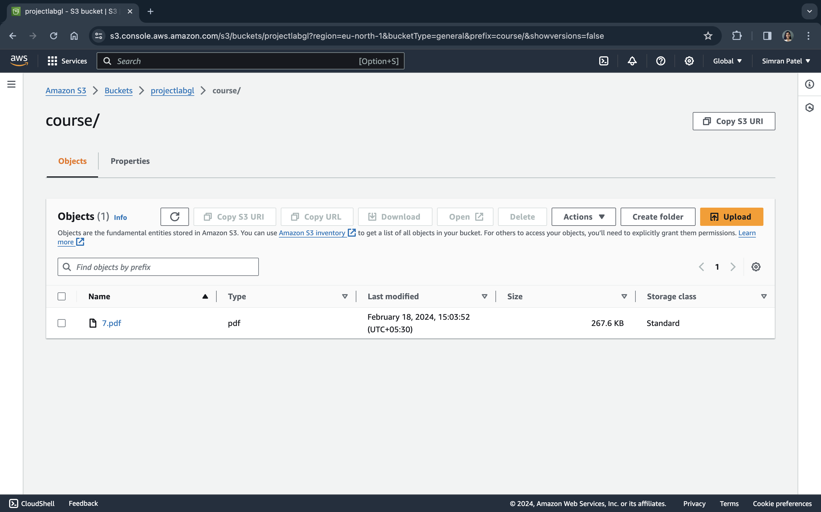

After adding new files to source bucket via cloud shell or CLI, observe that the destination bucket also gets affected via the replication rule.

The destination bucket has option to replicate the source only with the rule of allow to entire bucket or any specific content in the bucket.

To delete files from both the buckets we have to enable delete markup option.

Adding versioning will help us to understand that files added in the bucket are having delete marker option as well as which will tell us that latest edited date and time for the contents.